**Effects of fine particulate matter (PM2.5) and meteorological factors on the**

**daily confirmed cases of COVID-19 in Bangkok during 2020-2021, Thailand**

Sarawut Sangkhama,*, Md. Aminul Islamb,c, Kritsada Sarnthongd, PatipatVongrunga,e, Mohammad Nayeem Hasanf, Ananda Tiwarig, Prosun Bhattacharyah,*

a Department of Environmental Health, School of Public Health, University of Phayao, Phayao 56000, Thailand

b COVID-19 Diagnostic lab, Department of Microbiology, Noakhali Science and Technology University, Noakhali-3814, Bangladesh

c Advanced Molecular Lab, Department of Microbiology, President Abdul Hamid Medical College, Karimganj, Kishoreganj, Bangladesh

d Department of Community Health, School of Public Health, University of Phayao, Phayao 56000, Thailand

e Atmospheric Pollution and Climate Change Research Unit, School of Energy and Environment, University of Phayao, Phayao 56000, Thailand

f Department of Statistics, Shahjalal University of Science & Technology, Sylhet, Bangladesh

g Expert Microbiology Unit, Department of Health Security, Finnish Institute for Health and Welfare, 70701, Kuopio, Finland

h COVID-19 Research, Department of Sustainable Development, Environmental Science and Engineering, KTH Royal Institute of Technology, Teknikringen 10B, SE 10044 Stockholm, Sweden

**\* Corresponding author:** sarawut.sa@up.ac.th (**Asst. Prof. Sarawut Sangkham**), Department of Environmental Health, School of Public Health, University of Phayao, Phayao 56000, Thailand, +66 5446 6666 ext. 3233; prosun@kth.se (**Prof. Dr.Prosun Bhattacharya**), COVID-19 Research, Department of Sustainable Development, Environmental Science and Engineering, KTH Royal Institute of Technology, Teknikringen 10B, SE 10044 Stockholm, Sweden

**Highlights**

* Effects of RH, AH, and rainfall on the daily COVID-19 cases in BKK.
* COVID-case relationship to RH with a threshold of RH ≤ 66%.
* COVID-cases were found related to AH and rainfall.
* Meteorological factors also can have a role in the dissemination of SARS-CoV-2.
* Still inconclusive between PM2.5, meteorological factors to COVID-19 cases.

**Abstract**

The ongoing COVID-19 contagious disease occurred by SARS-CoV-2 has disrupted global public health, businesses, and economics due to widespread infection. Although, it is thought that environmental factors correlate to increase risk of COVID-19, however still the evidence is not clear. In this study correlation between PM2.5, PM10, and meteorological factors of COVID-19 infection is demonstrated in Bangkok, Thailand. Generalized Additive Model (GAM) was employed to investigate the impacts of RH, AH, and rainfall and which showed a positive nonlinear correlation with the number of COVID-19 confirmed cases within the threshold of ≤ 66%, >19 g/m3, and > 3 mm, respectively. While comparing the trend data from modified GAMs and COVID-19 case trends, it was also revealed that the seasons (mainly summer) and rainfall had statistically significant (*p*<0.05) effects on the trajectory of COVID-19 cases. The study results assist to prevent the future seasonal spread of COVID-19, and public health authorities may use these findings to make informed decisions and assess their policies.

**Keywords:** Particulate matter; PM2.5; Meteorological parameters; Rianfall; COVID-19 pandemic; Bangkok

**Abbreviations:** GAM,Generalized Additive Model; PM2.5, Particulate Matter 2.5; WHO, World Health Organization; DDC, Department of Disease Control; PCD, The Pollution Control Department; ACE-2, Angiotensin-converting enzyme 2; RH, Relative humidity; AH, Absolute humidity; AQI, Air Quality Index

**1. Introduction**

SARS-CoV-2 (COVID-19), a novel coronavirus disease reported in 2019, is one of the deadliest forms of pandemic influenza, which occurred 636 million confirmed cases and 6 million death cases around the world (1, 2). This infectious virus has quickly transmitted over the world within a very short time and is counted as a major public health concern (3-5). There are several potential influenza-like symptoms with an incubation period of 2 to 12 days for SARS-CoV-2 infections, where the mode of transmission is still unclear (6, 7). According to recent reports from the World Health Organization (WHO), the Delta variant (B.1.617.2) and Omicron (B.1.1.529) have been identified as fast-moving transmission variant of the Coronavirus (2, 8-11). The first formal notification of COVID-19-verified cases by DDC in Thailand was issued on January 12, 2020 (12)). According to several studies, long-term exposure to specific air pollutants makes COVID-19 more severe and complicated for those who have contracted the disease to recover from (13). Wu et al. (2020a) observed in earlier investigations that an increase in PM2.5 by only 1 g/m3 was related to an 8% rise in COVID-19 mortality (95% CI: 2 %-15%)(14). Long-term exposure to outdoor air pollutants is known to promote chronic lung inflammation, a condition that may contribute to the COVID-19 disease's increased severity as a result of the SARS-CoV-2 virus(15). Populations exposed to high levels of PM2.5 particles are therefore more prone to experiencing respiratory conditions that are conducive to infectious pathogens(16). Additionally, it was discovered that evidence suggests that prolonged exposure to ambient air pollution may increase COVID-19 mortality(14, 17). Weather-related air pollution could modify the host's immunity and the virus's ability to survive, which could influence the patterns of severe acute respiratory syndrome viral outbreaks(18). Numerous investigations conducted worldwide have revealed that COVID-19-induced humidity plays a pivotal function in morbidity and death(19). Furthermore, AQI, NO2, PM2.5, and temperature are parameters that may endorse the ongoing transmission of COVID-19(20). A prior study found an association between COVID-19 cases and average changes in temperature worldwide(21). Additionally, the effects of weather and air pollution are also unknown, particularly regarding SARS-CoV-2 transmission and droplet aerosol dispersed into the environment.

Since previous studies were short-term and had the characteristics of different terrain and seasons in each country, Marquès and Domingo (2022) found it difficult to draw any firm conclusions about the relationship between meteorological factors, air pollution, and the daily number of COVID-19 cases(22). In addition, a short-term investigation in the Bangkok Metropolitan Regional by Sangkham et al. (2021) discovered a correlation between the number of regular COVID-19 cases and temperature, wind speed (WS), relative humidity (RH), and absolute humidity (AH)(23). It is mentioned worthy that, there was no relationship between rainfall and air pollution. The WHO set guidelines for PM10 and PM2.5, are two air pollutants that have been known to damage the respiratory system, contribute to COVID-19 binding, and elevate health risks if exposed during the COVID-19 pandemic. Especially PM2.5, which are small particles that enter the lower respiratory system. However, it is unclear how PM2.5 and meteorological conditions affect the pathogens in the environment(24).

There is inconclusive scientific evidence and challenges in studying the impact of air pollution and meteorological variables on the daily number of confirmed COVID-19 cases. We, therefore, evaluated the focus on consequences throughout 2020–2021 and provided a hypothesis related to the analysis of the association between meteorological conditions, PM2.5, and the number of daily COVID-19 cases in Bangkok. It could have important ramifications for pandemic containment both during and after.

**2. Materials and methods**

*2.1 Study area and data collection*

COVID-19 positive cases were collected for this study, which is confirmed by the Bangkok Metropolitan Administration (BMA) and reported by the Department of Disease Control (DDC), Ministry of Public Health of Thailand from January 1, 2020, to December 31, 2021(25). The Pollution Control Department (PCD), Ministry of Natural Resources, and Environment provided daily weather data including mean temperature, relative humidity, pressure, wind speed, rainfall, and particulate matter (PM2.5). The PCD of Thailand's air quality monitoring stations supplied meteorological and air pollution data. **Fig. 1** shows the study area, monitoring locations, and ID name (02T, 05T, 11T, 10T). The hourly observation data includes particulate matter, relative humidity, wind speed, and temperature (PM2.5).

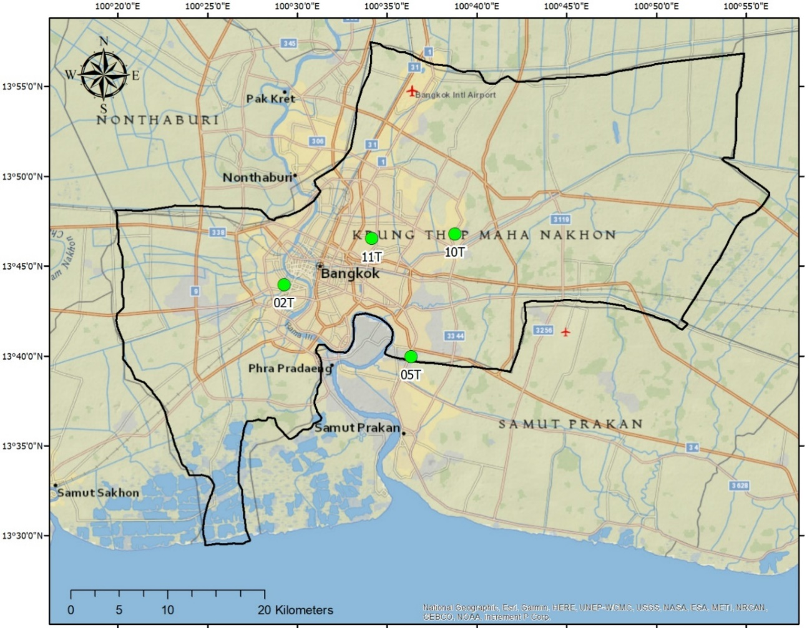

**Fig. 1** The location of the study area and the Air Quality Monitoring Station in BKK, The Pollution Control Department (PCD), Ministry of Natural Resources, and Environment

*2.2 Statistical analysis*

Generalized Additive Model (GAM) accommodates the generalized additive model for parametric, and nonparametric regression, as well as smoothing(26-28) (Liu et al., 2020a; Prata et al., 2020; Wu et al., 2018). The effect of weather, air pollution, and health outcomes were investigated using a log-linear GAM(5). Our fundamental model is a Gaussian response generalised additive model. The first step was to build the fundamental models, which included both air contaminants and meteorological parameters (temperature, RH, AH, WS, air pressure, and rainfall, and PM2.5. Second, the variables were modified to take the environment and individual characteristics, like wind speed, into consideration. To assess the daily average lag effect (Lag0-7, Lag0-14, and Lag0-21) of mean weather and air pollution on daily COVID-19 confirmed cases, a GAM with a Gaussian distribution family was used in this study(29-31). Third, the day-of-week and the penalized smoothing spline function were included to manage the time trend, as shown in the following Eq. 1:

(1)

Where, the date of the observation is is the day of the observed. Given the quantity of daily new cases in the Bangkok Metropolitan Area is, is the cases that were confirmed each day-on-day t plus one. The intercept is ; the regression coefficient is; the weather factors on day is; the relative humidity is; absolute humidity is ; rainfall is; and, the date of the observation is shown as ; the degree of freedom iswhich is based on the penalized smoothing spline;refers to the smoother. To account for any potential misalignment of a single lag day exposure, the lag effects of weather and air pollutants on daily new cases of COVID-19 were then considered using single lag days (lag0-7, 0-14, 0-21), and the cumulative effects of average exposure over multiple days were then assessed using additional analyses (Lag0-7, Lag0-14, Lag0-21)(32) (Wu et al., 2020b). We employed the R programme to conduct our analysis using GAM (version 4.2.1). Statistical significance was defined as *p* < 0.05 in these tests.

**3. Results and discussion**

*3.1 Descriptive analysis*

The study's findings indicated air and weather pollution in Bangkok Metropolitan from the COVID-19 descriptive statistics during the period of January 1, 2020, to December 31, 2021, (731 days) and **Fig. 2.** show daily of particulate matter (PM2.5), meteorological parameter, and COVID-19 cases in Bangkok Metropolitan Regions. The result show thatthere were 686.64 cases on average per BBK, and daily average values for temperature, relative humidity, absolute humidity, wind speed, pressure and, rain according to the meteorological data found 29.46 ๐C, 66.08%, 19.53 g/m3 0.87 m/s, where PM2.5 were 21.06 μg/m3 μg/m3, respectively (**Table S1**). The distribution of daily COVID-19 cases, PM2.5, and weather-related variables by year and season in BKK is shown in the **Fig. 3**, (2020-2021). Additionally, this study results showed that there were more than 6.32 mean confirmed instances, 19.85 g/m3 mean absolute humidity and an average temperature of 29.75 ๐C in the BBK in the year 2020 and the rate is significantly observed in 2021 differently. A rise in daily COVID-19 cases has been facing the pandemic due to a coronavirus variation to Omicron during July 2021 in BBK, with the mean confirmed cases in 2021 being 1144.96, absolute humidity being 19.21 g/m3, and temperature being 29.17 *๐*C. On the other hand, rest of the analyzed factors, do not demonstrate significant variations during the two years.

The results of a two-year study (2020–2021) revealed that there was no statistically significant difference between the PM2.5. In two years, there were 213 days in which the PM2.5 concentration was observed higher than the WHO (2018) threshold of a 24-hour mean of 25 µg/m3(33), or 23.14% of the days in which the standard was surpassed. It was discovered that the PM2.5 concentration in winter was 60.98% higher than the standard, followed by the summer at 33.52% and the rainy season at 0.98%. Additionally, the results showed that both PM2.5 exceeded the guideline of the WHO (2021c) upper limit at PM2.5: 5 µg/m3 (annual mean) and 15 µg/m3 (24 h)(34). The information in **Fig. 3** it is interesting to note that the cumulative number of COVID cases during the rainy season is greater than other seasons, while PM2.5 during the rainy season decreases. It is possible that the spread of COVID-19 may not be correlated. with PM2.5.

รูปภาพประกอบด้วย แผนภูมิ

คำอธิบายที่สร้างโดยอัตโนมัติ

**Fig. 2.** The daily of particulate matter (PM2.5), meteorological parameter, and COVID-19 cases in Bangkok Metropolitan Regions, from 1 January 2020 to 31 December 2021.

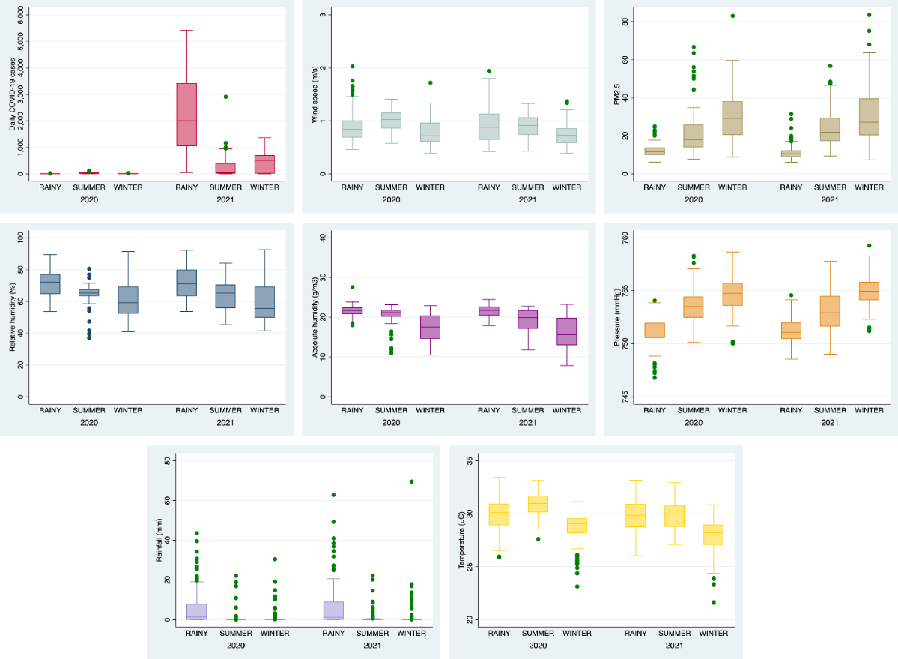

**Fig. 3.** Box plot distribution of yearly and season that shows daily COVID-19 cases and PM2.5, and meteorological parameters in BKK (2020-2021).

*3.2 Relationship between PM2.5, meteorological factors and daily COVID-19 cases*

**Fig. 4** shows the results of the relationship study using Spearman's Rank correlation coefficient between meteorological factors and particulate matter (PM2.5) with daily COVID-19 cases in BKK from 1 Jan 2020-31 Dec 2021. The resulth revealed that the correlation between COVID-19 instances is substantial for PM2.5, RH, AH, pressure, and rainfall variables at level 5% and for most pairings at level 0.1%. For instance, the COVID-19 instances showed a correlation between PM2.5 of -0.329, RH (0.297), AH (0.255), pressure (-0.280), and rainfall were also discovered to be correlated (0.241). The correlation coefficient indicates that the COVID-19 cases were positively correlated with the RH, AH, and rainfall and negatively correlated with PM2.5 and pressure. Given its location, BKK is either in the tropical or equatorial rainforest. This study selected variables with statistically significant positive correlation with daily COVID-19 cases, namely RH, AH, R, to study the effect of a 1 unit increase in mean meteorological with positive daily COVID-19 cases as follows shown in **Section 3.3.**

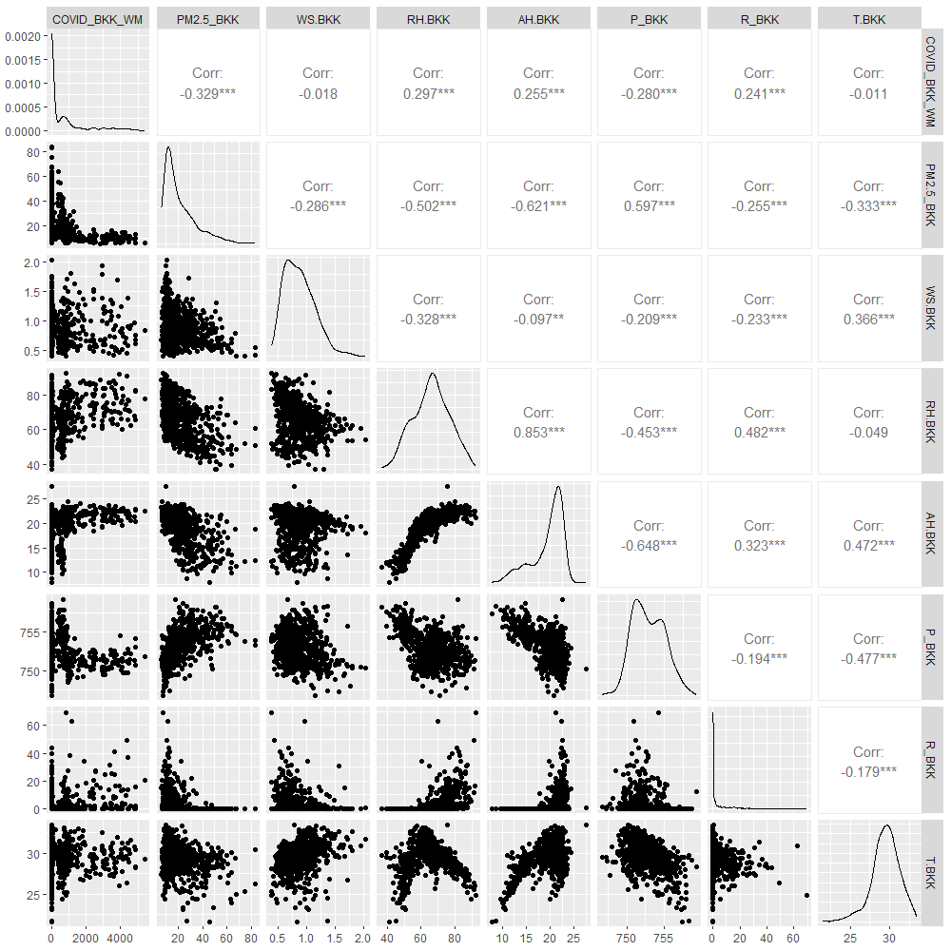

**Fig. 4.** Scatter plot of the Spearman's Rank correlation coefficient between meteorological factors and PM2.5 with daily COVID-19 cases in BKK from 1 Jan 2020-31 Dec 2021.

While, the study in Lombardy, Italy concluded that employing PM10 as a carrier would not allow for the COVID-19 diffusion mechanism to also occur through the air(35), which are the main routes of human-to-human transmission of respiratory viruses(36). Additionally, the propagation of SARS-CoV-2 is significantly hampered by the indoor environment(7). Therefore, PM may therefore increase infectious droplets and aerosols carrying the SARS-CoV-2 virus(37), in the environment where the person infected with COVID is spreading. According to Marquès et al. (2022)(38), patients with COVID-19, a serious condition, increase by 3.06% (95%CI: 1.11%-4.25%) when exposure to PM10 exceeds WHO recommendations by 1 µg/m3. Even though PM2.5 and PM10are inversely correlated with the prevalence of COVID-19, particles smaller than 2.5 microns can enter type 2 alveolar cells, which contain the intracellular receptor (ACE2) for SARS-CoV-2, causing an increase in the prevalence of coronavirus infections. Particles larger than 5 microns, however, cannot enter type 2 alveolar cells(39). Santurtn et al. (2022) also conducted a review and discovered the contribution of PM to the development of ACE-2 in respiratory cells in the human host and the clinical severity of the COVID-19-infected population(40). It was shown that PM may reflect human activity in each location with a high population density and that this activity may also help SARS-CoV-2 spread(37).

Meteorological studies found that a statistically significant positive correlation between RH and AH, and the number of daily COVID-19 cases, which is in line with findings from a study of Singapore meteorological factors, Similar to a study in India that covered 244 days, from January to August 2020(41), and a study conducted in Singapore revealed that the COVID-19 pandemic was linked to both RH and AH(42). Additionally, a study on Indian states discovered that relative and humidity-positive connections may have a significant impact on the fluctuation of COVID-19 case reproduction numbers(43). On the other hand, our study discovered a negative correlation between daily COVID-19 instances in Bangkok and temperature and wind speed. The average temperature was discovered to be adversely correlated with the frequency of COVID-19 cases, similar to research from Bangladesh and Rio de Janeiro, Brazil(44), Jakarta, Indonesia(45). In a different laboratory experiment, it was discovered that coronavirus on flat surfaces could survive for more than five days at temperatures between 22 to 25 ๐C and that at higher temperatures, viral vitality quickly vanished(46). Furthermore, it has been demonstrated that low temperatures and high relative humidity increase the aerosol transmission of respiratory viruses(47), whilst UV radiation (UV), which has wavelengths that can destroy RNA viruses, is frequently present in the general external atmosphere(47, 48), and SARS-CoV-2 transmission was reduced by hot climates and moderate outdoor UV exposure(49). Since the amount of sunlight hitting the earth's surface tends to raise temperature or heat, this may be one circumstance where warmer temperatures do not affect the daily incidence of coronavirus cases. According to reports, COVID-19 may also be disseminated through touch, human contact, coughing, sneezing, or droplet nuclei aerosol generated by an infected person(21).

Other factors can affect the rise or fall in the number of COVID-19 cases, such as lockdown measures, movement of the population in each country, exposure to both expressed and asymptomatic COVID-19 patients, and vaccination against COVID-19, because the spread of COVID-19 is not restricted to air pollution or meteorological factors only due to, leading to more lucid discussions and conclusions.

*3.3 Effects of RH, RH, and rainfall on daily COVID-19 confirmed cases in BKK*

In **Fig. 5**, the trend line for all meteorological variables by season and verified COVID-19 cases is shown. After one year of transmission, COVID-19 cases rose, with the wet season accounting for the majority of the rise. In the rainy season, when PM2.5 and pressure are at their lowest, wind speed and absolute humidity are also at their maximum levels. In addition to having the lowest temperature and maximum pressure, winter also has the highest pressure. GAM was utilized to analyze the impacts of relative humidity and temperature in prior work by Wu et al. (2020b)(32). It found that a 1 ๐C increase in temperature was associated with a 3.08% (95% CI: 1.53% -4.63%) decline in daily new COVID-19 cases, and a 1% increase in relative humidity was attributed to a 0.85% (95 % CI: 0.51 % -1.19 %) decline.

In order to evaluate the impact of RH, AH, and rainfall, respectively, above and below the threshold, a piecewise linear regression was modified based on the results from GAMs and thresholds of 66 %, 19 g/m3, and 3 mm were used. As shown in **Table 1** shows how daily COVID-19 cases are affected by a 1-unit rise in mean meteorology, our study discovered that RH 66 %, each 1% increase in mean RH (Lag0-7) resulted in a 1526.09 (95% CI: 970.38-2081.79) increase in the daily number of COVID-19 confirmed cases when mean RH was below 66 %, with a positive effect that was largest at Lag0-7 being statistically significant. Whenthe mean RH was above 66%, the positive effect of RH was not statistically significant. When mean AH was over 19 g/m3, each 1 g/m3 increase in mean AH (Lag0-7) resulted in a 1539.08 (95% CI: 809.09-2269.06) increase in the daily number of COVID-19 cases having a positive impact at Lag0-7. The positive effect of AH was not statistically significant when the mean AH was less than 19 g/m3. Additionally, when mean rainfall was above 3 mm, each 1 mm increase in decreased rainfall (Lag0-7) resulted in a 2925.09 (95% CI: 1689.77-4160.42) increase in the daily number of COVID-19 confirmed cases, but this increase was not statistically significant. It was statistically significant (*p*<0.001) that the favorable effect is greatest at Lag0-21 (COVID-19 cases = 4162.53, 95% CI: 2218.28-6106.77). The detrimental impact of rainfall was not statistically significant when the mean rainfall was less than 3 mm.

The study indicated that there was a significant nonlinear connection between RH and daily COVID-19 confirmed cases (Lag0-7, Lag0-14, and Lag0-21, at *p*<0.001). The relationship was specifically linear in the range of 66 % and flat above 66%, showing that 66% was the single threshold of the RH effect on SARS-CoV-2. According to additional findings, areas with less humidity (< 40% RH) have a higher risk of SARS-CoV-2 airborne transmission than areas with higher humidity (> 90% RH)(50). The transmission of the influenza virus was just as effective at lower RH (< 35%) as it was at higher RH (60-80%)(51). It has been hypothesized that the virus can persist in humid environments in water droplets beneath the physiological content of salt at high humidity, i.e., humidity >70%. When the humidity is between 40 and 60%, the evaporation that inactivates the viruses concentrates the salt, and when the humidity falls below 30%, the salt separates from the solution. This might permit the virus to continue to function(51, 52). Furthermore, indoor humidity dispersal is greatly reduced when relative humidity levels are lower than 40%(53). According to the results of the current investigation, the relative humidity ranged between 39% and 90% and was related to the daily incidence of COVID-19 cases. It suggested that RH might have an impact on the number of COVID patients in Bangkok. While AH will be proportional to the value of RH found that the association was roughly linear in the range of >19 g/m3 and became flat below 19 g/m3, demonstrating that the single threshold of the AH effect on COVID-19 was 19 g/m3. The relationship between AH and daily of COVID-19 cases was significant nonlinear (Lag0-7: *p*<0.001; Lag0-14: *p*<0.001; Lag0-21: *p*<0.004).The relationship was specifically linear in the range of 66 % and flat above 66%, showing that 66% was the single threshold of the RH effect on SARS-CoV-2. The association was roughly linear in the range of >19 g/m3 and became flat below 19 g/m3, demonstrating that the single threshold of the AH effect on COVID-19 was 19 g/m3. The relationship between AH and daily of COVID-19 cases was significant nonlinear (Lag0-7: *p*<0.001; Lag0-14: *p*<0.001; Lag0-21: *p*<0.004). In addition, it was fascinating to note that this study demonstrated a statically significant nonlinear association between daily COVID-19 confirmed cases and rainfall (lag0-7, lag0-14, and lag0-21 with *p*<0.001). To be more precise, the connection was somewhat linear in the range of >3 mm and went flat below 3 mm, showing that the single threshold of the rainfall influence on COVID-19 was 3 mm. Additionally, **Fig. 4,** demonstrates that the spine curve tended to rise in line with the rise in COVID-19 cases during the rainy season, which was influenced by meteorological conditions such as RH, AH, and rainfall.

**Table 1** The effect of a 1 unit increase in mean meteorological with positive daily COVID-19 cases in BKK during 2020-2021.

|  |  |  |  |  |  |  |
| --- | --- | --- | --- | --- | --- | --- |
|  | Mean RH ≤ 66% | | *p*-value | Mean RH > 66% | | *p*-value |
|  | Number of Case change | 95%CI |  | Number of Case change | 95%CI |  |
| Lag0-7 | 1526.09 | 970.38–2081.79 | <0.001* | 371.06 | -224.77–966.88 | 0.213 |
| Lag0-14 | 1493.55 | 936.32–2050.78 | <0.001* | 274.13 | -319.16–867.43 | 0.356 |
| Lag0-21 | 1345.27 | 807.74–1882.80 | <0.001* | 300.48 | -317.49–918.45 | 0.331 |
|  | Mean AH ≤ 19 g/m3 | | *p*-value | Mean AH > 19 g/m3 | | *p*-value |
|  | Number of Case change | 95%CI |  | Number of Case change | 95%CI |  |
| Lag0-7 | 571.42 | -119.85–1262.70 | 0.098 | 1539.08 | 809.09–2269.06 | <0.001* |
| Lag0-14 | 691.14 | -37.14–1419.42 | 0.058 | 1252.49 | 513.25–1991.73 | 0.001* |
| Lag0-21 | 658.64 | -22.49–1339.78 | 0.053 | 1092.91 | 340.14–1845.67 | 0.004* |
|  | Mean rainfall ≤ 3 mm | | *p*-value | Mean rainfall > 3 mm | | *p*-value |
|  | Number of Case change | 95%CI |  | Number of Case change | 95%CI |  |
| Lag0-7 | -92.45 | -659.51–474.61 | 0.744 | 2925.09 | 1689.77–4160.42 | <0.001* |
| Lag0-14 | -14.68 | -571.05–541.70 | 0.958 | 2501.63 | 1312.60–3690.65 | <0.001* |
| Lag0-21 | -642.59 | -1396.88–111.69 | 0.088 | 4162.53 | 2218.28–6106.77 | <0.001* |

* *p*<0.05



**Fig. 5.** Season-wise daily pattern of COVID-19 cases and climate factors, from 1 Jan 2020–31 Dec 2021 in BKK.

Nonetheless, it was discovered that the number of COVID-19 cases tended to decline statistically significantly in the summer when meteorological parameters were considered and the values were adjusted. According to the unadjusted model, as shown in **Table 2**, the estimated trend of COVID-19 cases on BBK increased at a rate of 640.27 (95% CI: 464.57 to 815.97) in the summer, and it likewise declined at a rate of 635.39 (95% CI: 452.94 to 817.83) in the corrected model. In both models, the association between COVID-19 instances and the summer season is statistically significant. The COVID-19 cases in this study also increased rainfall by 5.61 times in the adjusted model and 6.31 times in the unadjusted model. In accordance with the study, Xie and Zhu (2020) noted that when the climate warms, there is a tendency for fewer COVID-19 cases to occur(31). The seasonality of COVID-19's dissemination in Brazil has recently been documented by a study by Yin et al. (2022)(54). However, there is a significant relationship with the adjusted model, and there is no association between COVID-19 instances and rainfall in the unadjusted model. In COVID-19 cases, no other meteorological factors appear to be important. However, in COVID-19 cases, there was a negative association between PM and wind speed. The effects of the season, relative humidity, pressure, and rainfall are favorable for COVID-19 instances. The season (summer and monsoon), however, had a statistically significant positive connection with the trend in the number of COVID-19 cases after the variables were adjusted.

We evaluated how the weather impacted COVID-19 transmission in BBK using the GAM model approach. Our study shows that COVID-19 infections are significantly affected positively or negatively by variations in the weather. However, the findings don't seem to apply to both the adjusted and unadjusted models. In contrast to humidity and pressure, which are positively correlated with COVID-19 transmission in raw models and negatively correlated in adjusted models, respectively, temperature and pressure have a relationship with humidity and pressure. We found that wind speed had a negative impact on COVID-19 transmission in both correlation and GAM models, which is consistent with other earlier studies(55). Recent studies claimed that there was no link between wind speed and COVID-19 transmission, even though our correlation and the adjusted GAM model corroborate this finding(56, 57).

Our findings showed that the temperature had both a direct and indirect impact on the transmissibility of COVID-19, even though it was not significant in correlation analysis, adjusted or unadjusted model(57, 58) (Gupta et al., 2020; Menebo, 2020). A positive link between COVID-19 occurrences has previously been demonstrated in numerous study reports(59-62). Additionally, several additional studies reported no association between temperature and the incidence of COVID-19(63) or an inverse relationship similar to our unadjusted model that is also consistent with the findings of our GAM model(32). Due to oxidative stress and airway inflammation that is brought on by prolonged exposure to high PM levels and poor air quality, which encourages viral transmission and adverse respiratory effects, the host becomes more vulnerable to respiratory infections(13). We discovered a negative link between PM2.5 and COVID-19 death counts, which is similar to research that established a negative relationship between PM2.5 and PM10 and COVID-19 death counts in Wuhan, China(64). Increased air pollution is strongly correlated with a higher incidence of verified COVID-19 cases, according to numerous studies, which have either indicated the opposite or a positive correlation(55, 56). This study revealed that the trend of COVID-19 cases in the Bangkok Metropolitan Region was influenced by meteorological parameters like season and rainfall. This is further supported by the fact that Omicron spreads and infects more quickly than earlier strains that affected the 2021 pandemic(65, 66). According to findings from Mei et al. (2020)(67), Oran and Topol (2020)(68), and WHO (2021a)(9), many of these illnesses have both symptomatic and asymptomatic signs. Additionally, SARS-CoV-2 mutations as well as person-to-person interaction in densely populated or indoor places may be to blame for the sharp increase in the daily number of cases.

**Table 2** Trend results from unadjusted and adjusted GAMs and COVID-19 cases trends.

|  |  |  |  |  |
| --- | --- | --- | --- | --- |
| Parameter | Unadjusted (95% CI) | *p*-value | Adjusted (95% CI) | *p*-value |
| Season |  |  |  |  |
| Summer | 650.03* (643.68 to 656.38) | <0.001 | 656.41* (649.95 to 662.88) | <0.001 |
| Winter | 117.87 (111.41 to 124.33) | 0.186 | 125.92 (119.28 to 132.55) | 0.170 |
| PM2.5(μg/m3) | -2.03 (-2.17 to -1.89) | 0.297 | -3.36 (-3.52 to -3.21) | 0.118 |
| Wind speed (m/s) | -163.30* (-167.98 to -158.62) | 0.012 | -143.25 (-149.20 to -137.29) | 0.082 |
| Relative humidity (%) | 4.09* (3.95 to 4.23) | <0.001 | 1.73 (0.70 to 2.76) | 0.903 |
| Absolute humidity (g/m3) | 12.46 (11.92 to 13.01) | 0.099 | -5.80 (-9.55 to -2.05) | 0.911 |
| Pressure (mmHg) | 6.31* (6.15 to 6.48) | 0.006 | -2.56 (-3.54 to -1.57) | 0.851 |
| Rainfall (mm) | 10.33* (10.33 to 12.07) | 0.352 | 5.74* (5.57 to 5.92) | 0.019 |
| Temperature (๐C) | -9.20 (-10.09 to -8.31) | 0.455 | 9.17 (5.55 to 12.79) | 0.854 |
| **Model diagnosis for adjusted model** | | | |  |
| Adjusted R-square | |  | 0.852 |  |
| Deviance explained | |  | 85.60% |  |
| AIC |  |  | 10914.24 |  |

* Significant at *p*<0.05. Akaike Information Criteria: AIC.

*3.4 Limitations of the study*

There could be an underreported numerator value in the published data (daily COVID-19 confirmed cases). Numerous variables, such as how the government handled the cases, whether there were enough restrictions, any festivals, lockdowns, population immunity, social behavior, as well as the tourist season and population migrations, could cause the daily number of COVID-19 confirmed cases to be misinterpreted. Additionally, rain reduces PM levels in the air because it removes dust particles from the atmosphere. It is risky to release data such as this one, though, as many other important factors might have an impact and increase the number of cases during the rainy season, independent of the weather. The quantity in the air is decreased by natural wash during the rainy season. There may have been an increase in COVID-19 because the government has been measuring during rain here in Thailand. Accordingly, we have found a negative association between PM2.5 and COVID-19. The immune system of humans is lowered by PM in the air, and SARS CoV-2 particles may linger in the air for a longer period and spread from a sick to a healthy person even if we had assumed a positive correlation. Future research should take into account these criteria when assessing the long-term effects of the integrated meteorological variables, lockdown, state COVID-19 protection measures (such as lockdown, population migration, human mobility, or immunization), and the COVID-19 cases in BKK.

**4. Conclusion**

The long-term correlation between climatic parameters and PM2.5 with verified daily COVID-19 instances in BKK has never been analyzed in a nonlinear manner before. Our research revealed a linear relationship between mean RH, AH, and rainfall, and the daily number of confirmed COVID-19 cases when the RH is below 66%, and AH and rainfall are over 19 g/m3 and 3 mm respectively. Summer and monsoon were shown to have an impact on trend results via adjusted GAMs and COVID-19 instances. The model diagnostic for adjusted R-square was 0.852 with deviance explained at 85.60% and was statistically significant at *p*<0.05. A few complicating factors, including patients with asymptomatic symptoms of COVID-19 infection, immunization, socioeconomic factors, SARS-CoV-2 variations, and topographic considerations, should also be addressed herein. Additional research is required to determine whether the meteorological conditions, vaccinations, air pollutants, and medical histories of those infected with SARS-CoV-2 could prevent COVID-19 during and after the pandemic. These findings will aid in the choice of policymakers to prevent future outbreaks and contracting respiratory infection disorders as well as the information obtained can be used to plan future seasonal COVID-19 vaccination.

**Funding**

No funding.

**Declaration of competing interest**

The authors declare that they have no known competing financial interests or personal relationships that could have appeared to influence the work reported in this paper.

**Acknowledgments**

The authors would like to thank the Air Quality and Noise Management Bureau, Pollution Control Department (PCD), and Ministry of Natural Resources and Environment for the secondary data of air pollutants and meteorological parameter data; the dataset of the updated daily number of confirmed COVID-19 cases was obtained from the official webpage of the Department of Disease Control (DDC), Ministry of Public Health, Thailand.

**References**

1. Ahmed F, Islam MA, Kumar M, Hossain M, Bhattacharya P, Islam MT, et al. First detection of SARS-CoV-2 genetic material in the vicinity of COVID-19 isolation Centre in Bangladesh: Variation along the sewer network. Science of The Total Environment. 2021;776:145724.

2. Islam MA, Haque MA, Rahman MA, Hossen F, Reza M, Barua A, et al. A Review on Measures to Rejuvenate Immune System: Natural Mode of Protection Against Coronavirus Infection. Frontiers in Immunology. 2022;13.

3. Ju MJ, Oh J, Choi Y-H. Changes in air pollution levels after COVID-19 outbreak in Korea. Science of The Total Environment. 2021;750:141521.

4. Sakib MMH, Nishat AA, Islam MT, Raihan Uddin MA, Iqbal MS, Bin Hossen FF, et al. Computational screening of 645 antiviral peptides against the receptor-binding domain of the spike protein in SARS-CoV-2. Computers in Biology and Medicine. 2021;136:104759.

5. Zhu Y, Xie J, Huang F, Cao L. Association between short-term exposure to air pollution and COVID-19 infection: Evidence from China. Science of The Total Environment. 2020;727:138704.

6. Lauer SA, Grantz KH, Bi Q, Jones FK, Zheng Q, Meredith HR, et al. The Incubation Period of Coronavirus Disease 2019 (COVID-19) From Publicly Reported Confirmed Cases: Estimation and Application. Annals of Internal Medicine. 2020;172(9):577-82.

7. Piscitelli P, Miani A, Setti L, De Gennaro G, Rodo X, Artinano B, et al. The role of outdoor and indoor air quality in the spread of SARS-CoV-2: Overview and recommendations by the research group on COVID-19 and particulate matter (RESCOP commission). Environmental Research. 2022;211:113038.

8. Islam A, Hossen F, Rahman A, Sultana KF, Hasan MN, Haque A, et al. An opinion on Wastewater-Based Epidemiological Monitoring (WBEM) with Clinical Diagnostic Test (CDT) for detecting high-prevalence areas of community COVID-19 Infections. Current Opinion in Environmental Science & Health. 2022:100396.

9. WHO. Classification of Omicron (B.1.1.529): SARS-CoV-2 Variant of Concern. 2021.

10. WHO. COVID-19 weekly epidemiological update, 12 January 2021. 2021 2021-01-12.

11. WHO. Coronavirus disease (COVID-19) Weekly Epidemiological Update and Weekly Operational Update. 2022.

12. DDC. 2020.

13. Domingo JL, Rovira J. Effects of air pollutants on the transmission and severity of respiratory viral infections. Environmental Research. 2020;187:109650.

14. Wu X, Nethery RC, Sabath MB, Braun D, Dominici F. Air pollution and COVID-19 mortality in the United States: Strengths and limitations of an ecological regression analysis. Science Advances. 2020;6(45):eabd4049.

15. Coker ES, Cavalli L, Fabrizi E, Guastella G, Lippo E, Parisi ML, et al. The Effects of Air Pollution on COVID-19 Related Mortality in Northern Italy. Environmental and Resource Economics. 2020;76(4):611-34.

16. Mehmood K, Saifullah, Iqbal M, Abrar MM. Can exposure to PM2.5 particles increase the incidence of coronavirus disease 2019 (COVID-19)? Science of The Total Environment. 2020;741:140441.

17. Hoang T, Tran TTA. Ambient air pollution, meteorology, and COVID-19 infection in Korea. Journal of Medical Virology. 2020;n/a(n/a).

18. Cai Q-C, Lu J, Xu Q-F, Guo Q, Xu D-Z, Sun Q-W, et al. Influence of meteorological factors and air pollution on the outbreak of severe acute respiratory syndrome. Public Health. 2007;121(4):258-65.

19. Srivastava A. COVID-19 and air pollution and meteorology-an intricate relationship: A review. Chemosphere. 2021;263:128297.

20. Li H, Xu X-L, Dai D-W, Huang Z-Y, Ma Z, Guan Y-J. Air pollution and temperature are associated with increased COVID-19 incidence: A time series study. International Journal of Infectious Diseases. 2020;97:278-82.

21. Iqbal MM, Abid I, Hussain S, Shahzad N, Waqas MS, Iqbal MJ. The effects of regional climatic condition on the spread of COVID-19 at global scale. Science of The Total Environment. 2020;739:140101.

22. Marquès M, Domingo JL. Positive association between outdoor air pollution and the incidence and severity of COVID-19. A review of the recent scientific evidences. Environmental Research. 2022;203:111930.

23. Sangkham S, Thongtip S, Vongruang P. Influence of air pollution and meteorological factors on the spread of COVID-19 in the Bangkok Metropolitan Region and Air Quality during the Outbreak. Environmental Research. 2021:111104.

24. Lolli S, Chen Y-C, Wang S-H, Vivone G. Impact of meteorological conditions and air pollution on COVID-19 pandemic transmission in Italy. Scientific Reports. 2020;10(1):16213.

25. DDC. 2022.

26. Liu J, Zhou J, Yao J, Zhang X, Li L, Xu X, et al. Impact of meteorological factors on the COVID-19 transmission: A multi-city study in China. Science of The Total Environment. 2020;726:138513.

27. Prata DN, Rodrigues W, Bermejo PH. Temperature significantly changes COVID-19 transmission in (sub)tropical cities of Brazil. Science of The Total Environment. 2020;729:138862.

28. Wu X, Lang L, Ma W, Song T, Kang M, He J, et al. Non-linear effects of mean temperature and relative humidity on dengue incidence in Guangzhou, China. Science of The Total Environment. 2018;628-629:766-71.

29. Hastie TJ. Generalized additive models. Statistical Models in S2017. p. 249-307.

30. Liu K, Hou X, Ren Z, Lowe R, Wang Y, Li R, et al. Climate factors and the East Asian summer monsoon may drive large outbreaks of dengue in China. Environmental Research. 2020;183:109190.

31. Xie J, Zhu Y. Association between ambient temperature and COVID-19 infection in 122 cities from China. Science of The Total Environment. 2020;724:138201.

32. Wu Y, Jing W, Liu J, Ma Q, Yuan J, Wang Y, et al. Effects of temperature and humidity on the daily new cases and new deaths of COVID-19 in 166 countries. Science of The Total Environment. 2020;729:139051.

33. WHO. Ambient (outdoor) air pollution. 2018.

34. WHO. Ambient (outdoor) air pollution. 2021.

35. Bontempi E. First data analysis about possible COVID-19 virus airborne diffusion due to air particulate matter (PM): The case of Lombardy (Italy). Environmental Research. 2020;186:109639.

36. Domingo JL, Marquès M, Rovira J. Influence of airborne transmission of SARS-CoV-2 on COVID-19 pandemic. A review. Environmental Research. 2020;188:109861.

37. Ishmatov A. “SARS-CoV-2 is transmitted by particulate air pollution”: Misinterpretations of statistical data, skewed citation practices, and misuse of specific terminology spreading the misconception. Environmental Research. 2022;204:112116.

38. Marquès M, Correig E, Ibarretxe D, Anoro E, Antonio Arroyo J, Jericó C, et al. Long-term exposure to PM10 above WHO guidelines exacerbates COVID-19 severity and mortality. Environment International. 2022;158:106930.

39. Copat C, Cristaldi A, Fiore M, Grasso A, Zuccarello P, Signorelli SS, et al. The role of air pollution (PM and NO2) in COVID-19 spread and lethality: A systematic review. Environmental Research. 2020;191:110129.

40. Santurtún A, Colom ML, Fdez-Arroyabe P, Real Ád, Fernández-Olmo I, Zarrabeitia MT. Exposure to particulate matter: Direct and indirect role in the COVID-19 pandemic. Environmental Research. 2022;206:112261.

41. Gautam S, Samuel C, Gautam AS, Kumar S. Strong link between coronavirus count and bad air: a case study of India. Environment, Development and Sustainability. 2021;23(11):16632-45.

42. Pani SK, Lin N-H, RavindraBabu S. Association of COVID-19 pandemic with meteorological parameters over Singapore. Science of The Total Environment. 2020;740:140112.

43. Manik S, Mandal M, Pal S, Patra S, Acharya S. Impact of climate on COVID-19 transmission: A study over Indian states. Environmental Research. 2022;211:113110.

44. Rosario DKA, Mutz YS, Bernardes PC, Conte-Junior CA. Relationship between COVID-19 and weather: Case study in a tropical country. International Journal of Hygiene and Environmental Health. 2020;229:113587.

45. Rendana M. Impact of the wind conditions on COVID-19 pandemic: A new insight for direction of the spread of the virus. Urban Climate. 2020;34:100680.

46. Chan KH, Peiris JSM, Lam SY, Poon LLM, Yuen KY, Seto WH. The Effects of Temperature and Relative Humidity on the Viability of the SARS Coronavirus. Advances in Virology. 2011;2011:734690.

47. Audi A, AlIbrahim M, Kaddoura M, Hijazi G, Yassine HM, Zaraket H. Seasonality of Respiratory Viral Infections: Will COVID-19 Follow Suit? Frontiers in Public Health. 2020;8.

48. Lytle CD, Sagripanti J-L. Predicted Inactivation of Viruses of Relevance to Biodefense by Solar Radiation. Journal of Virology. 2005;79(22):14244-52.

49. Xu R, Rahmandad H, Gupta M, DiGennaro C, Ghaffarzadegan N, Amini H, et al. Weather, air pollution, and SARS-CoV-2 transmission: a global analysis. The Lancet Planetary Health. 2021;5(10):e671-e80.

50. Ahlawat A, Wiedensohler A, Mishra SK. An Overview on the Role of Relative Humidity in Airborne Transmission of SARS-CoV-2 in Indoor Environments. Aerosol and Air Quality Research. 2020;20(9):1856-61.

51. Yuan S, Jiang S-C, Li Z-L. Do Humidity and Temperature Impact the Spread of the Novel Coronavirus? Frontiers in Public Health. 2020;8.

52. Yang W, Elankumaran S, Marr LC. Relationship between Humidity and Influenza A Viability in Droplets and Implications for Influenza’s Seasonality. PLOS ONE. 2012;7(10):e46789.

53. Skanata A, Spagnolo F, Metz M, Smyth DS, Dennehy JJ. Humidity Reduces Rapid and Distant Airborne Dispersal of Viable Viral Particles in Classroom Settings. Environmental Science & Technology Letters. 2022;9(7):632-7.

54. Yin C, Zhao W, Pereira P. Meteorological factors' effects on COVID-19 show seasonality and spatiality in Brazil. Environmental Research. 2022;208:112690.

55. Zoran MA, Savastru RS, Savastru DM, Tautan MN. Assessing the relationship between surface levels of PM2.5 and PM10 particulate matter impact on COVID-19 in Milan, Italy. Science of The Total Environment. 2020;738:139825.

56. Bashir MF, Ma B, Bilal, Komal B, Bashir MA, Tan D, et al. Correlation between climate indicators and COVID-19 pandemic in New York, USA. Science of The Total Environment. 2020;728:138835.

57. Menebo MM. Temperature and precipitation associate with Covid-19 new daily cases: A correlation study between weather and Covid-19 pandemic in Oslo, Norway. Science of The Total Environment. 2020;737:139659.

58. Gupta S, Raghuwanshi GS, Chanda A. Effect of weather on COVID-19 spread in the US: A prediction model for India in 2020. Science of The Total Environment. 2020;728:138860.

59. Islam N, Shabnam S, Erzurumluoglu AM. Temperature, humidity, and wind speed are associated with lower Covid-19 incidence. medRxiv. 2020:2020.03.27.20045658.

60. Nottmeyer LN, Sera F. Influence of temperature, and of relative and absolute humidity on COVID-19 incidence in England - A multi-city time-series study. Environmental Research. 2021;196:110977.

61. Shi P, Dong Y, Yan H, Li X, Zhao C, Liu W, et al. The impact of temperature and absolute humidity on the coronavirus disease 2019 (COVID-19) outbreak - evidence from China. medRxiv. 2020:2020.03.22.20038919.

62. Tong L, Ji L, Li D, Xu H. The occurrence of COVID-19 is associated with air quality and relative humidity. Journal of Medical Virology. 2022;94(3):965-70.

63. Poirier C, Luo W, Majumder MS, Liu D, Mandl KD, Mooring TA, et al. The role of environmental factors on transmission rates of the COVID-19 outbreak: an initial assessment in two spatial scales. Scientific Reports. 2020;10(1):17002.

64. Ma Y, Zhao Y, Liu J, He X, Wang B, Fu S, et al. Effects of temperature variation and humidity on the death of COVID-19 in Wuhan, China. Science of The Total Environment. 2020;724:138226.

65. Callaway E. Why does the Omicron sub-variant spread faster than the original? Nature. 2022;602(7898):556-7.

66. Kannan S, Shaik Syed Ali P, Sheeza A. Omicron (B.1.1.529) - variant of concern - molecular profile and epidemiology: a mini review. European review for medical and pharmacological sciences. 2021;25(24):8019-22.

67. Mei X, Zhang Y, Zhu H, Ling Y, Zou Y, Zhang Z, et al. Observations about symptomatic and asymptomatic infections of 494 patients with COVID-19 in Shanghai, China. Am J Infect Control. 2020;48(9):1045-50.

68. Oran DP, Topol EJ. Prevalence of Asymptomatic SARS-CoV-2 Infection. Annals of Internal Medicine. 2020;173(5):362-7.